#LoveSquash Product Order Form

You can order branded #LoveSquash t-shirts and bumper stickers for yourself, your friends and your club. The design of the t-shirt and bumper stickers can be seen on page 2.

An order is not confirmed until payment has been fully received (this includes payment for postage and goods).

Squash New Zealand requires a minimum number of t-shirts and bumper stickers to be ordered before an order will be placed with our providers BLK and PrintHouse. The minimum number of t-shirts required is 25 whilst the minimum number of bumper stickers required is 100. Orders will be placed with our providers on the following dates if the minimum quantity has been reached.
- Friday 2nd March
- Friday 23rd March
- Friday 14th April
Squash New Zealand will communicate the expected timeline as orders are placed and minimum quantities are or are not met.

Contact name
Delivery address
N.B. Cannot be a P.O. Box

Please indicate how many t-shirts you would like to order of each size:
Adult T-Shirt ($26 incl. GST) | S | M | L | XL | XXL | 3XL | 4XL | 5XL
Quantity Adults Shirts
Ladies T-Shirt ($26 incl. GST) | LS | LM | LL | LXL | LXXL | L3XL
Quantity Ladies Shirts
Youth T-Shirt ($26 incl. GST) | YXS | YS | YM | YL | YXL
Quantity Youth Shirts
Shirt sizes can be found below

Shipping Costs | Cost incl. GST | Quantity
1-3 Shirts | $6.89
4-6 Shirts | $9.13
7-10 Shirts | $12.93
10+ Shirts | Please contact Squash NZ Directly to discuss your options
Rural Delivery | $3.90
1-15 Bumper Stickers | $2.00
15-40 Bumper Stickers | $3.00
40+ Bumper Stickers | Please contact Squash New Zealand Directly to discuss your options
Total Cost
Total Number of Shirts_______ @$26 each incl. GST _________
Total Number of Bumper Stickers________ @$2 each incl. GST _________
Shipping Option____________ _________
Rural Delivery_____________ _________
Sum _________
Bank Details: Westpac Henderson
Account Number: 03-0155-0304279-00
Account Name: New Zealand Squash Incorporated
Swift Code: WPACNZ2W
N.B. Please include your First and Last Name as above in the reference of the bank deposit.
#LoveSquash Bumper Stickers

Dimensions Length 13cm x Height 10cm

#LoveSquash T-Shirts

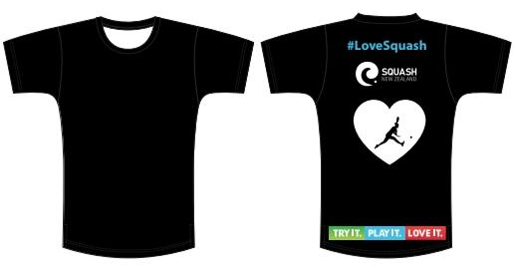

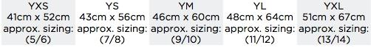
Youth Sizes

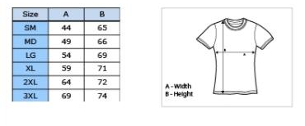
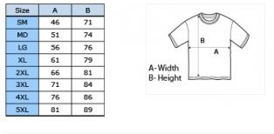
Men’s Sizes Women’s Sizes

