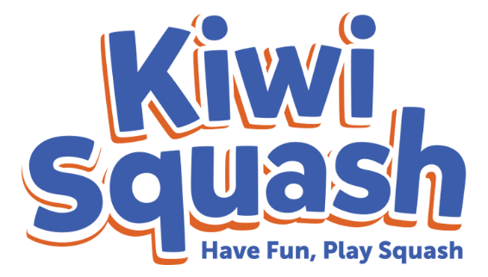
School Expression of Interest Form (YEAR)

For more information: www.kiwisquash.com

School Details

School
Contact person
Email address
Phone number

Programme Information

Developed in 2014, Kiwi Squash is a Squash New Zealand branded junior programme that clubs and schools can run, aimed at engaging primary (Small Nix 5-8yrs) and intermediate (9-12yrs) school-aged children in squash-based activities. Kiwi Squash is delivered collaboratively by teachers, qualified coaches and club volunteers, creating strong and healthy communities with links between schools and local clubs and using world-leading coaching resources.

The programme involves purchasing equipment, printing materials and contracting coaches and/or volunteers to deliver the prescribed 8 week programme to targeted schools. Each individual session consists of skill development, technique, general movement and coordination activities and games for students. At the end of the 8 weeks, students and staff are provided with resources for ongoing participation at the school level and will be advised of any community club opportunities. Should they wish, schools can also purchase their own equipment and can run the programme each year thereafter.

The programme includes:
- A comprehensive resource manual that outlines 8 complete lesson plans with learning outcomes, illustrations, questions to ask and can you see prompts
- A DVD visual aid, demonstrating over 60 activities
- Parent and teacher information leaflets
- Promotional posters
- A range of equipment and equipment packs
- Specialised training and support to run the programme

Other Information

Does your school have a Kiwi Squash kit set?
How many classes are interested in participating?

When would you be interested in running a Kiwi Squash programme?

Term 1 | Term 2 | Term 3 | Term 4

This form is an expression of interest only. Your local Squash Club and/or Squash District will be in contact to discuss the Kiwi Squash programme once the form has been received.

