CalendarWiz
How to: change view
Click one of these to view the calendar in different formats – once you have a format you can click on an event for more details
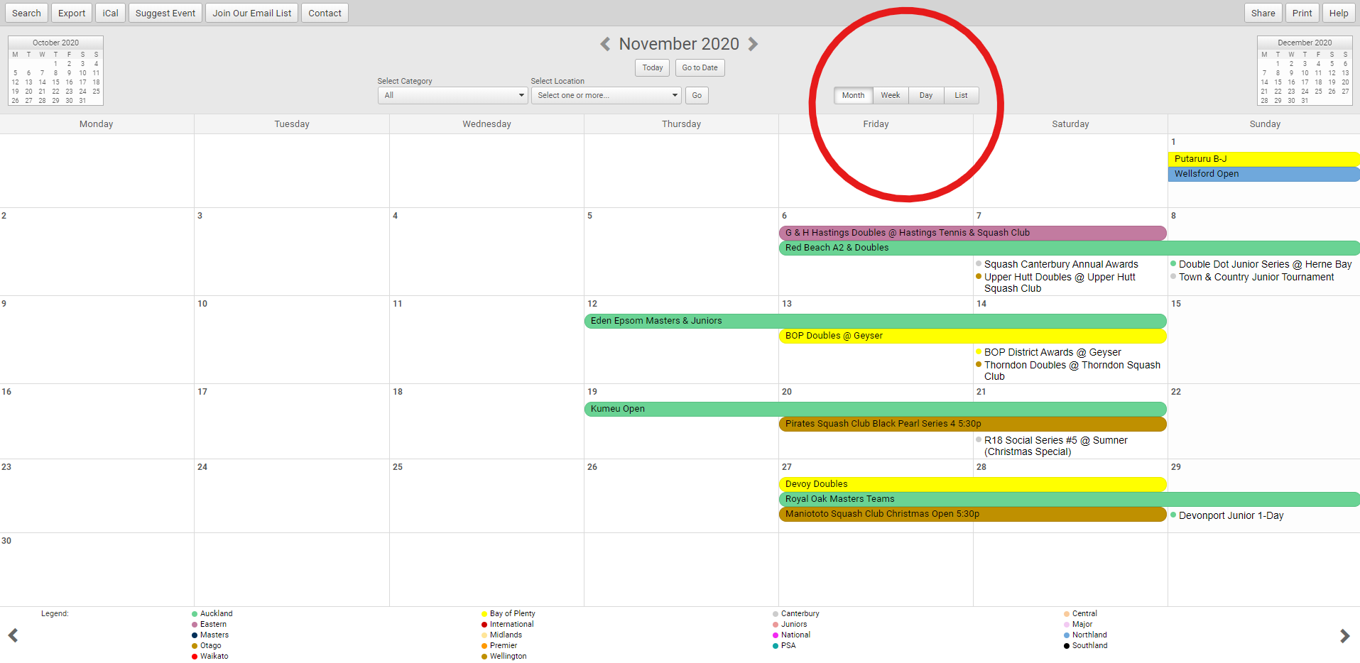

How to: Select a Date
Click go to date and scroll to find your date – then press go
Or to go back or forward a month – click on one of the boxes to either side
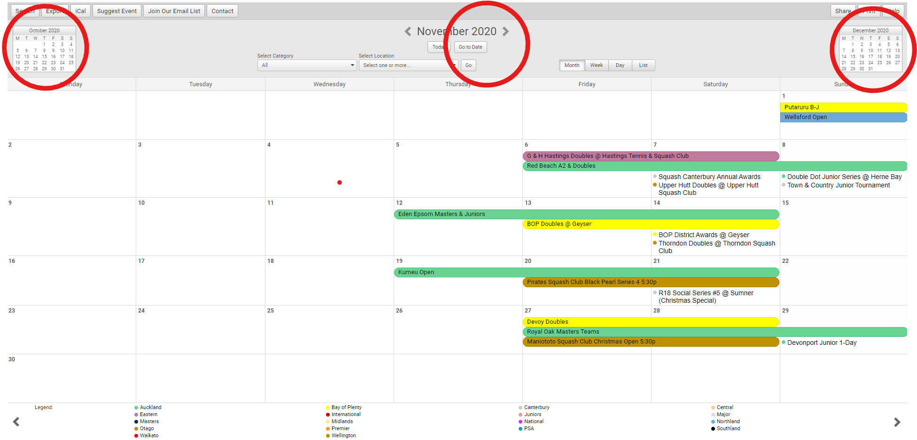

How to: Search – Option 1
Select Category and press go.
Categories: All Districts, Premier: events run by SNZ, Major: Events run by Districts, PSA, International
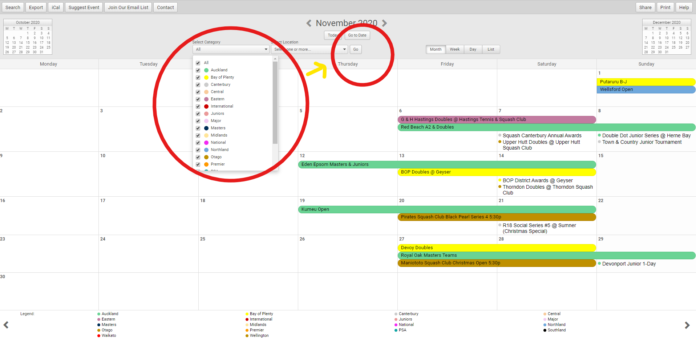

How to: search - Option 2
Click search up the top left
Enter date range – Category – submit search
All events found will show up – click the bottom left corner to expand and see everything
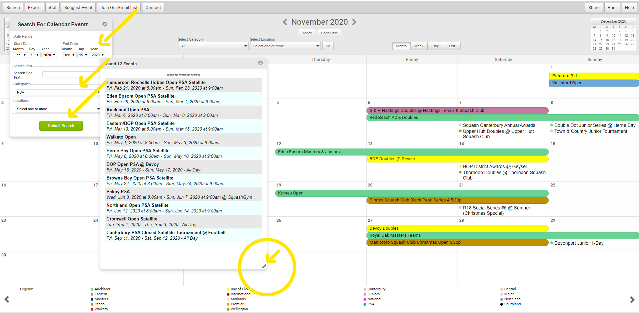

How to: Export
Click export up the top left.
You can pick your format: excel or ical to go straight into your email calendar.
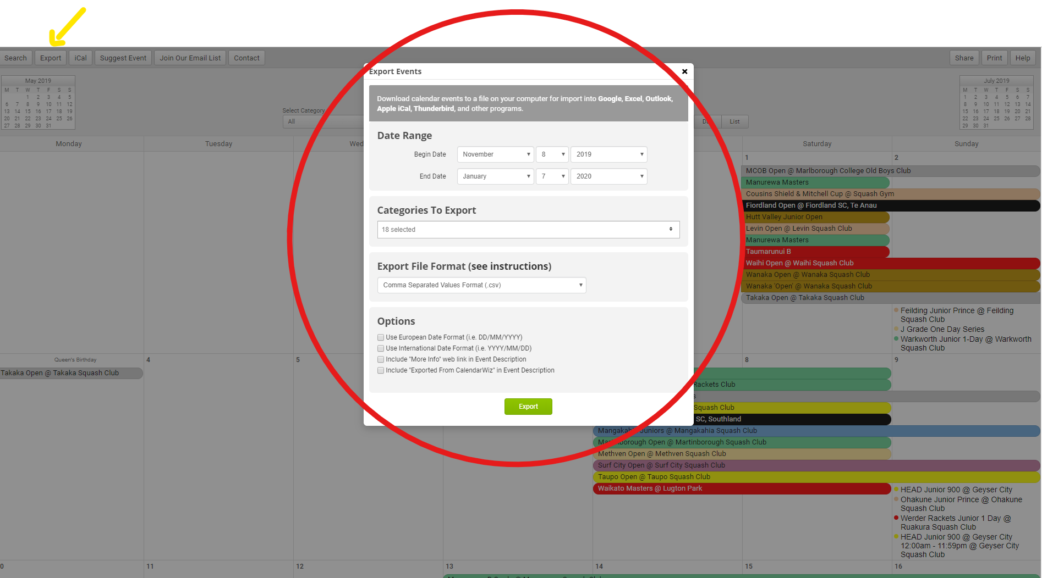
How to: suggest an event
Click suggest event up top left
Fill in everything with red Asterix – from here we will approve/decline event in conjunction with your District.
