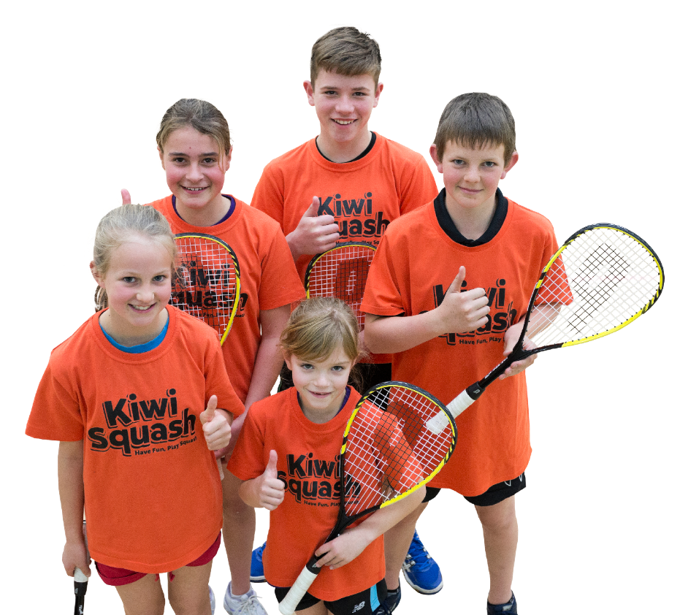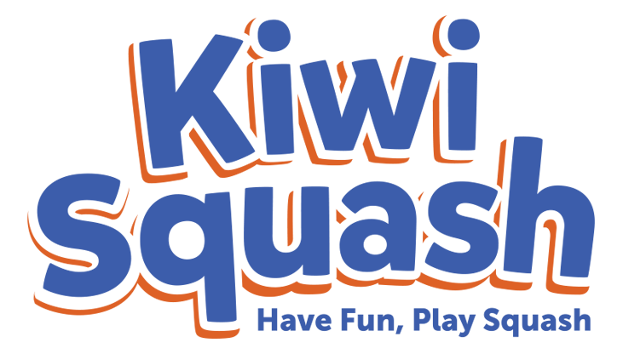

Add any pertinent information here. For example…

Come along to Junior Squash with qualified coaches and a fun eight-week programme.

We’ll teach children the basics of

squash in a fun but structured environment.

At the end of the programme,

all children are invited to join

the club and participate in

tournaments and interclub.

Parents are welcome to watch

the sessions.

When: [eg. Monday nights 5-6pm]

Dates: [eg. from Monday 9 June until 28 July

Where: [squash club name and physical address]

Cost: [eg. $20 or $2/night]

Contact: [name of contact with phone number and/or email]

**Fun Junior Squash for all ages and levels – beginners welcome!**