PARKING TIPS
(SAMPLE ONLY)

Things to remember so you spend less time parking and more time playing squash!

- The entrance to the club is via Z Avenue.
- During the week between 7am and 5pm you can park in car park (accessible from Y Street).
- You can park for FREE for up to 120 mins in designated areas Monday to Friday from 5pm.
- There are 20 car parks available. Only use the car parks when you are using the facilities.
- Paid parking is available at the Parking Depot.
- Make sure you clearly display a parking sticker on your vehicle.
- Parking is free on the streets surrounding the club between 6pm and 8am.
- Don’t forget the blue option – there are plenty of spaces for bicycles and scooters.
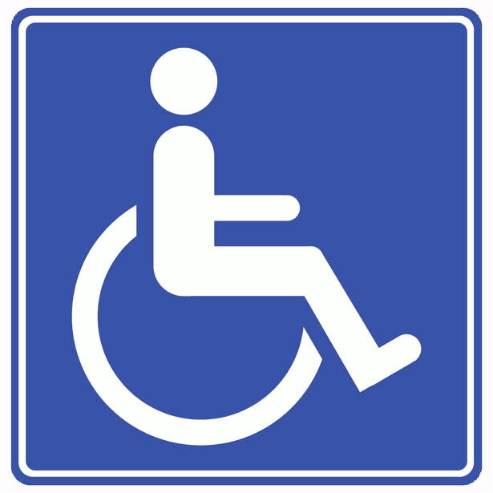
- There are also bus stops in the immediate vicinity of the club.
Parking Depot

Y Street
SQUASH CLUB

Main Road
Z Avenue
Bus Stop
CARPARK x 20

