Risk Management Process

Risk management is a systematic way of identifying, assessing, treating and monitoring risks. This process helps you to make plans to reduce the potential negative consequences, such as serious harm to your club and its’ people.

Causal Factors
There are three categories of hazard that can cause risk. These are:
- People
- Equipment
- Environment

Risks
When identifying risks (forms of loss) there are 5 main categories:
- Damage to the environment / surrounds (s)
- Loss or damage to equipment (e)
- Injury / illness (i)
- Financial loss (f)
- Loss of credibility (c)

Risk Assessment
Having identified the risks involved we need to assess them in terms of their likelihood to occur. Each identified risk must be rated to describe:
- The likelihood of the risk occurring (likelihood); and
- The loss or damage impact if the risk occurred (severity); and
- The priority, or degree of urgency required to address the risk

Likelihood
Rating | Likelihood
5 | ALMOST CERTAIN: Will probably occur, could occur several times per activity/event
4 | LIKELY: High probability, likely to arise once during the activity/event
3 | POSSIBLE: Reasonable likelihood that it may arise over the activity/event
2 | UNLIKELY: Plausible, could occur over a the activity/event
1 | RARE: Very unlikely but not impossible, unlikely for this activity/event

Severity
Rating | Potential Impact
5 | CATASTROPHIC: Most objectives may not be achieved, or several severely affected
4 | MAJOR: Most objectives threatened, or one severely affected
3 | MODERATE: Some objectives affected, considerable effort to rectify
2 | MINOR: Easily remedied, with some effort the objectives can be achieved
1 | NEGLIGIBLE: Very small impact, rectified by normal processes

Priority
10/9 | Extreme risks that are likely to arise and have potentially serious consequences requiring urgent attention
8/7 | Major risks that are likely to arise and have potentially serious consequences requiring urgent attention or investigation
6/5 | Medium risks that are likely to arise or have serious consequences requiring attention
4/3 | Minor risks and low consequences that maybe managed by routine procedures
2/1 | Almost no consequence risk, very unlikely to happen

Management Plan
When managing risks there are 3 options: Prevent, Isolate or Minimise. You should choose the option that most effectively and practically manages the issue.

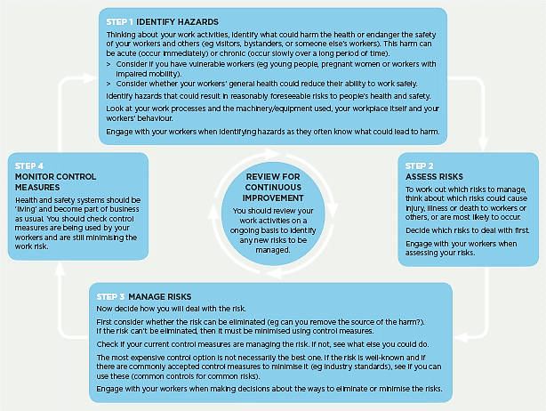
For more information: Click here

